Hans and Charlotte Jepsen

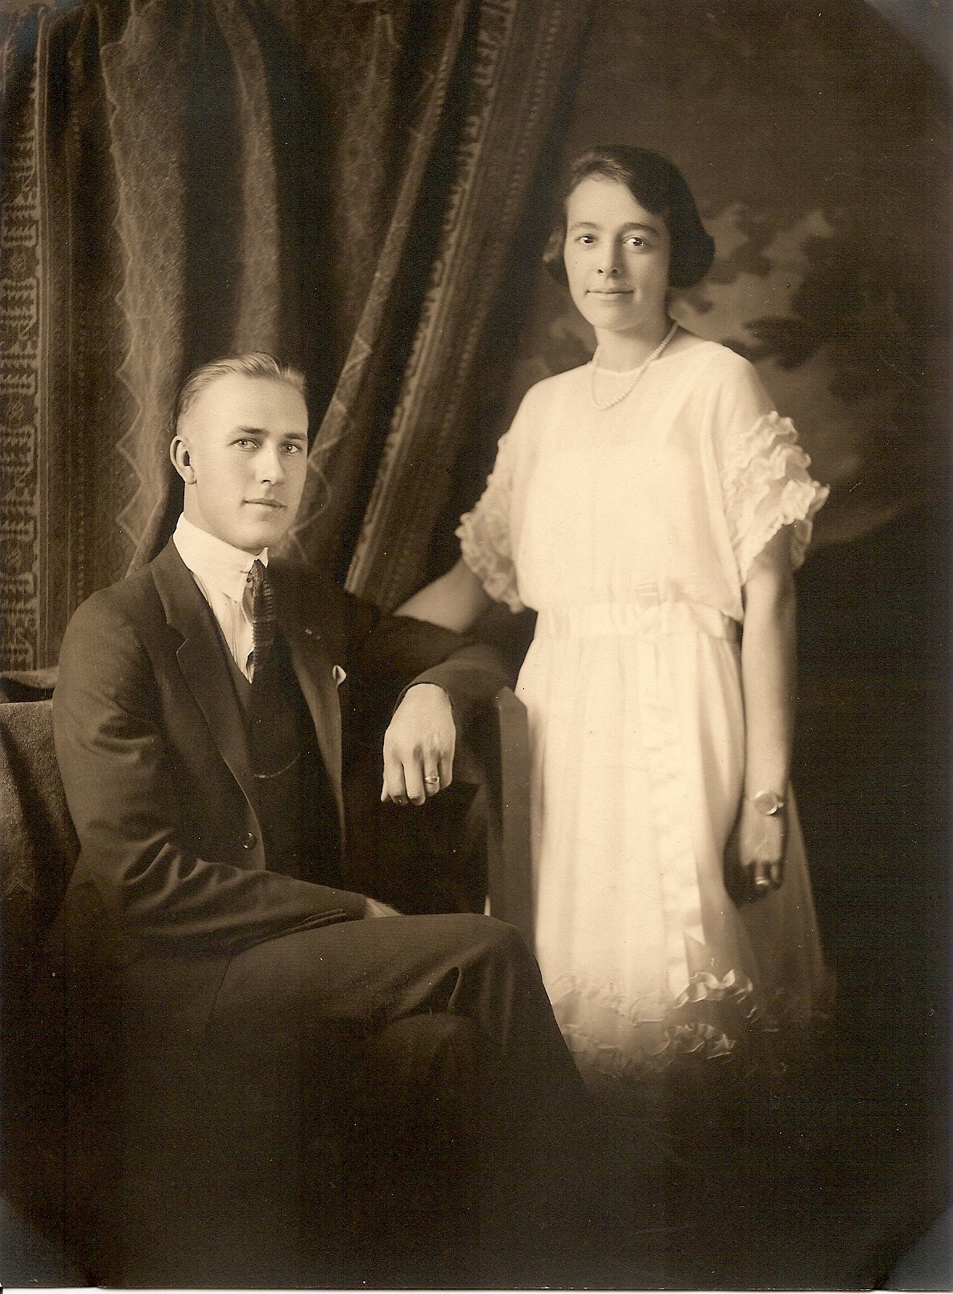

Hans R. Jepsen and Charlotte Lovegrove married on July 24, 1922.

They had three sons: Ray, and twins Bob and John. Charlotte had spent her youth summering in Glenbrook with the Hunting family, as she was helping Mrs. Hunting with her three sons. The Jepsens purchased the lot in Glenbrook in 1938 and had the house built in 1939. The family lived in Minden, but spent their summers at the lake from that point on. The house is one of the few homes in Glenbrook to remain with the original family.

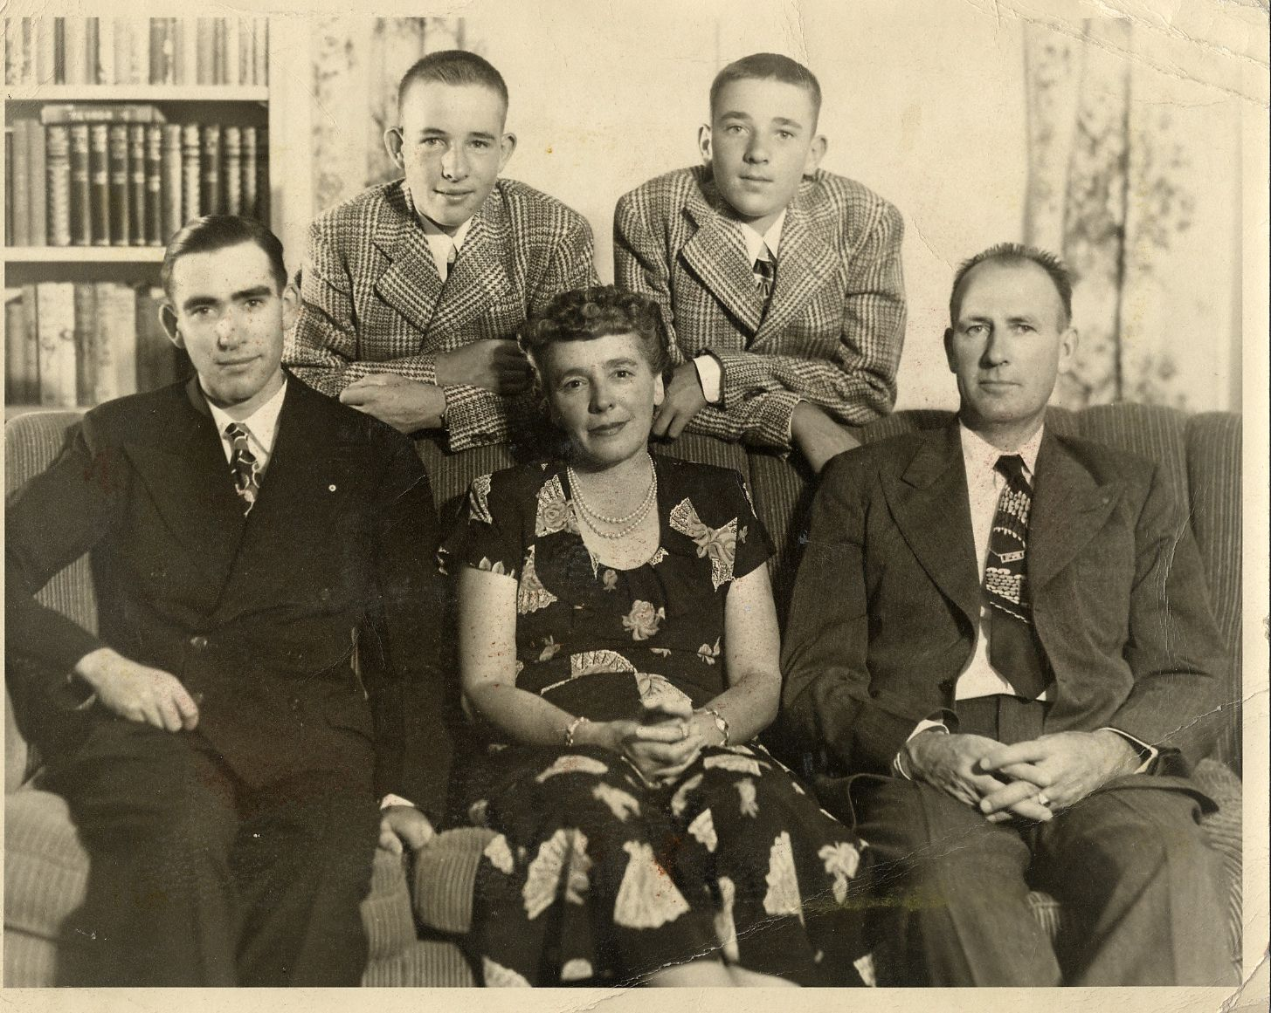

The Jepsens in approximately 1952
Back: twins John and Bob
Front: Ray, Charlotte, Hans

Charlotte named their home Sawmill Harbor because it overlooks Lake Tahoe and the historic pilings of an 1876-era pier that served a sawmill. A train would go out onto the pier with cars filled with logs that had been harvested from the mountainsides. The logs were discharged into the lake and were floated to one of the sawmills in Glenbrook. At one time there were six separate sawmills. More information on this can be found in the history section of this notebook.
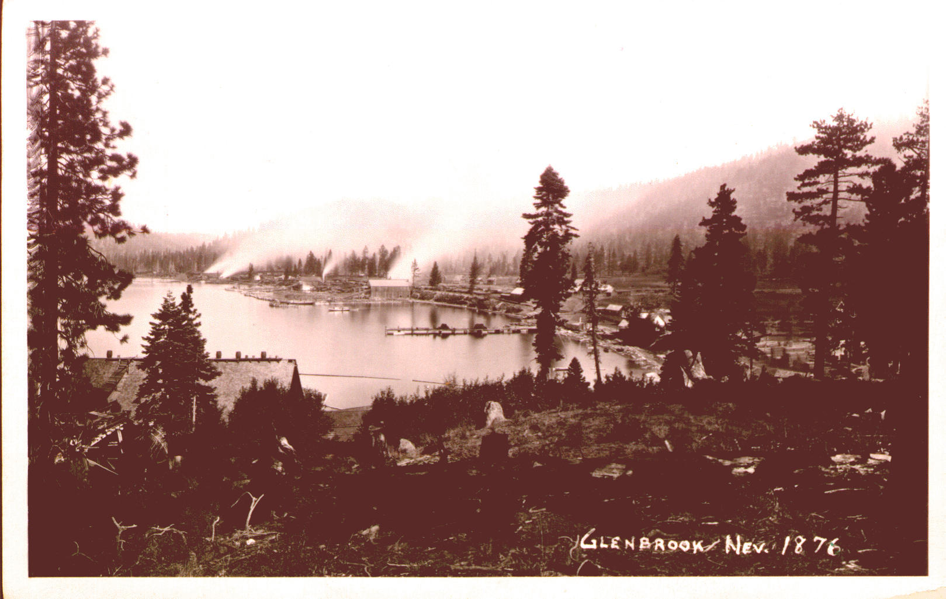
HOME

